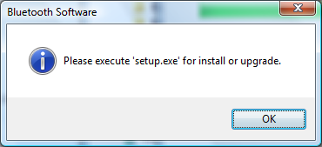

I click ok but it keeps popping up.

